**Report**

**DEVELOP A JAVA PROGRAM TO PRINT ELECTRICTY BILL USING DEFAULT ARGUMENTS**

**1.0Retionale:**

In this project we have learnt how to generate electricity bill using default arguments. In this project we have accepted the no. of customer, name and units from the user and then displayed the bill using default. The users are charged as per following rates:

100 units=Rs.1.50 p/unit

200 units=Rs.1.80 p/unit

Beyond 200 Rs.2.50 p/unit

All users are charged a minimum of the total amount is more than 300 then an additional surcharge of 15% is added.

**2.0Aim of the micro project:**

The micro project aims at generation of electricity bill using default arguments.

**3.0Course outcomes:**

a) We have performed a simple java program to print electricity bill using default arguments.

**5.0Actual Methodology followed:**

|  |  |  |
| --- | --- | --- |
| **Sr. no.** | **Details of activity** | **Name of Responsible Team Member** |
| 1. | Information | Saurabh gavali |
| 2. | Proposal | Saurabh gavali, Sunny yadav, Shardul lokhande, Saurabh singh, Sachin yadav, Praveen prajapati |
| 4. | Program | Saurabh singh,Sachin yadav |
| 5. | Demonstration of program | Sunny yadav, Shardul lokhande, |
| 6. | Report | Sunny yadav, Praveen prajapati |

**6.0Actual resources used:**

|  |  |  |  |  |
| --- | --- | --- | --- | --- |
| **Sr.no.** | **Name of resource/material** | **specifications** | **Qty** | **Remarks** |
| 1. | Notepad, java | Jdk1.8.0  For windows 7 | 1 |  |
| 2. | Microsoft word 2013 | Microsoft office 2013 | 1 |  |

**7.0Output of the micro project:**

**Code:**

import java.util.*;

class Electric

{

int cno;

String name;

double unit;

double bill=0;

void accept()

{

Scanner sc=new Scanner(System.in);

System.out.println("Enter customer number:");

cno=sc.nextInt();

System.out.println("Enter customer name:");

name=sc.next();

System.out.println("Enter number of units:");

unit=sc.nextDouble();

if(unit>0 && unit<=100)

bill=(50+(unit*1.50));

else if(unit>100 && unit<=200)

bill=(50+(unit*1.50)+(unit*1.80));

else if(unit>200)

bill=(50+(unit*2.50));

if (bill>300)

bill=(bill+(bill*(15/100)));

}

void display()

{

System.out.println("Customer number:"+cno+"\nCustomer name is"+name+"\nBill="+bill);

}

public static void main(String args[])

{

int i,count;

Electric ec[]=new Electric[100];

Scanner sc=new Scanner(System.in);

System.out.println("Enter for how many customers:");

count=sc.nextInt();

for(i=0;i<count;i++)

{

ec[i]=new Electric();

ec[i].accept();

}

for(i=0;i<count;i++)

{

ec[i].display();

}

}

}

**Output:**

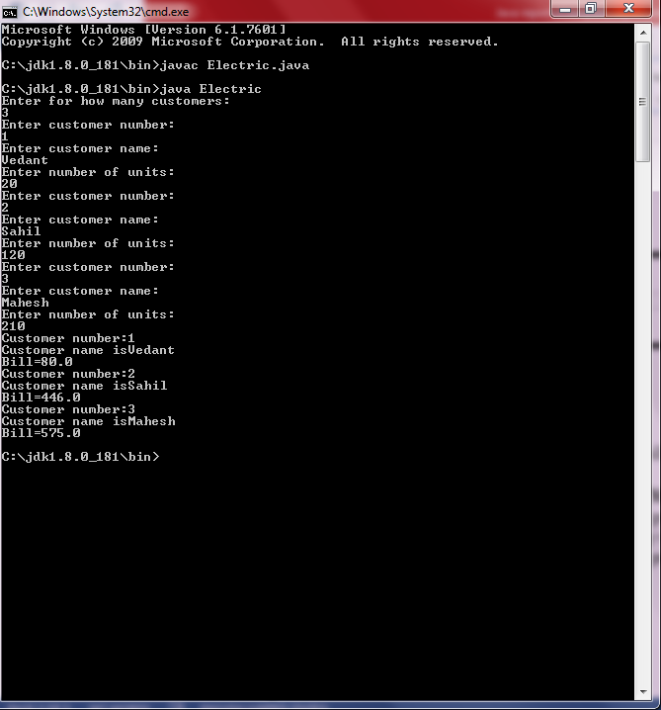

**8.0Skill developed/learning out of this Micro-Project:**

Hence, we have learned making simple java programs. While working on this project we learned to co-ordinate and function smoothly with fellow group members thereby leading in to proper implementation and execution of the project assigned.

**9.0 Application of this Micro-Project:**

a) Mobile bill payment

b) Usage check

**Bibliography:**

[**www.wikipedia.com**](http://www.wikipedia.com)

[**www.btech.com**](http://www.btech.com)

Subject in-charge

Kashif shaikh